**CSE320: Data Communications**

**Quiz-1 (Set – A)**

**Total Marks: 20**

**Name: ID: Sec:**

1. For the following Multi-level ASK, find the bit stream form the signal below: [4]

| | Bit Pattern | Amplitude | | --- | --- | | 00 | 1V | | 01 | 3V | | 10 | 4V | | 11 | 0V | |  |
| --- | --- | --- | --- | --- | --- | --- | --- | --- | --- | --- | --- |

2. Draw the analog signal for the digital bit stream 101100011000 using Multi-level FSK where 2 bits at a time get transmitted. [Amplitude of the Carrier Signal = 3V and phase = 0 rad, Number of Cycles of the signal element for different Bit Patterns: 00: 4, 01: 3, 10: 1, 11: 2] [4]

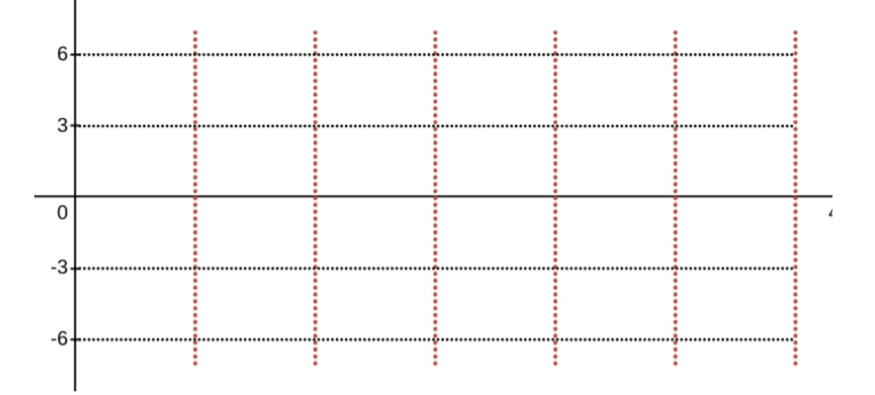

3. Draw the analog signal for the bit stream 0011101101 using the constellation diagram given below [frequency = 2 for each signal element and amplitude = 6V] [4]

|  |  |
| --- | --- |

4. If the value of Δf = 3, what is the difference between the carrier signals in FSK? [4]

5. Draw the constellation diagram for the following case. Find the peak amplitude value and define the type of the modulation (ASK/ FSK/ PSK). The numbers in parentheses define the values of I (In-phase Carrier) and Q (Quadrature Carrier) respectively. [4]

* Four points at (5, 5), (−5, 5), (−5, −5), and (5, −5)